1. Creating chat bots using chat completion

Chat Completions API is used to pass a list messages to the model as input.

And receive a model generated response as a output.

GPT -3.5 or 4 model – conversation In and message out

In here not convert messages to Tokens. Just sent series of messages.

**Code -**

1. **Install library**

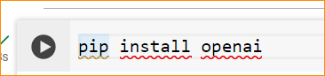

If OpenAI has released a package with that name since then, you may want to check their official documentation or announcements for installation instructions. If you're referring to the OpenAI API Python client, you can install it via pip using the following command:



The [datalib] suffix in pip install openai[datalib] indicates that you're trying to install additional dependencies required for using the OpenAI Data API. This command will install the openai package along with its datalib extras.



Urllib3 is a powerful and user-friendly HTTP client library for Python. It allows you to make HTTP requests and handle responses in a convenient and efficient manner



Running pip install python-dotenv installs the python-dotenv package, which is a Python library for managing environment variables from a .env file. This package is commonly used in Python applications to load environment variables from a file named .env in the root directory of the project.

1. **Import the libraries and environment file to gain access to the Open API Key**

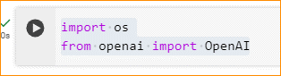

import the OpenAI class from the openai module, but it's important to note that there's no direct import of OpenAI like that from the openai package.If you're attempting to use the OpenAI API, you might need to import specific components provided by the openai package.

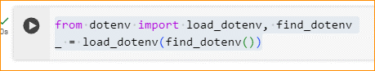

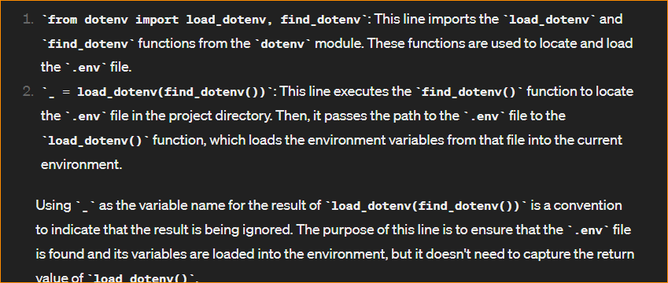

1. **Authenticate to the API using the API Key**

Pull from environment variables or use api_key = ("your_key_here") to hardcode the key

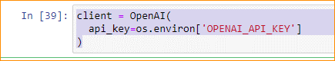

1. **Building a Project with the ChatGPT API**

Completion API that u can crate is limit less.

Completion API using text in , text out format.

Input is a simple text prompt with the model generating output that matches the context or pattern you provided.

Completion API is backed by a traditional GPT model that consuming unstructured text which you already know is represented to the model as a sequence of tokens.

Example –

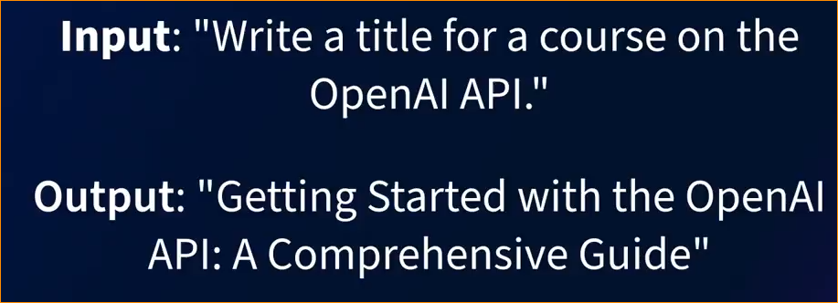

Its shown different result again and again-

Ex –

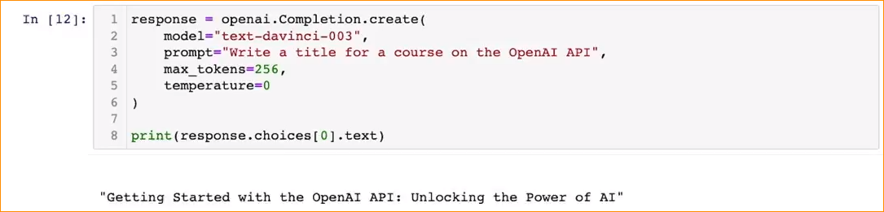

Response is -

This happen the model is considered stochastic.

Different between chat Completion API and Completion API ?

The "Chat Completion API" and "Completion API" are both interfaces that allow developers to interact with OpenAI's language models to generate text based on given prompts.

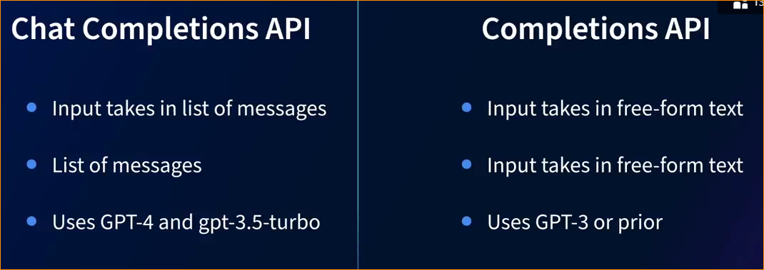

1. Building relatedness using embeddings

Embedding API – measures similarities of text string by mapping text and code to vector.

This is transform text in to a sequence of floating point numbers.

This nyumaric representation of text enables machine learning models and algorithms to comprehend the connections and associations among concepts more easily.

The distance between two vectors measures their relatedness.

Ex- if two pieses of texts are similar there vector representation also similar.

Embedding offering –

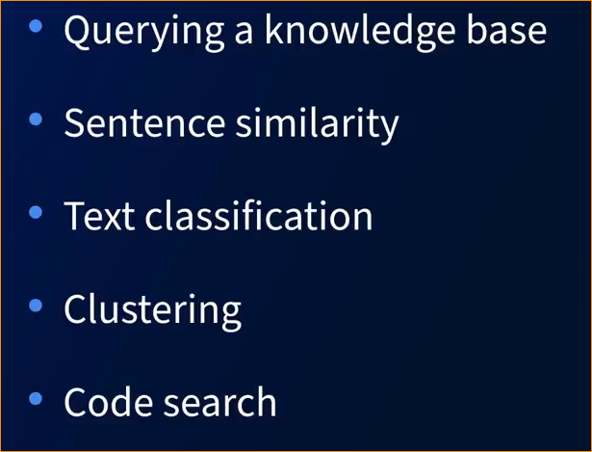

Embedded API in Action –

Example –

We have 2 examples –

“the cat is sitting on the mat”

“the dog is stting on the rug”

Using embedding convert this in to numbers –

Cat -

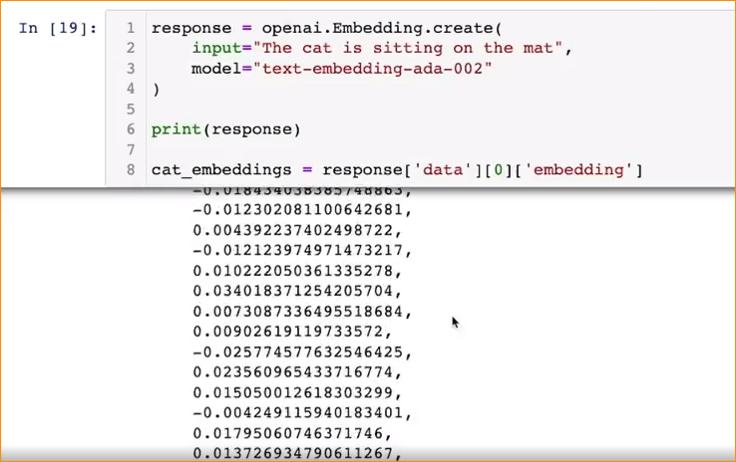

Dog –

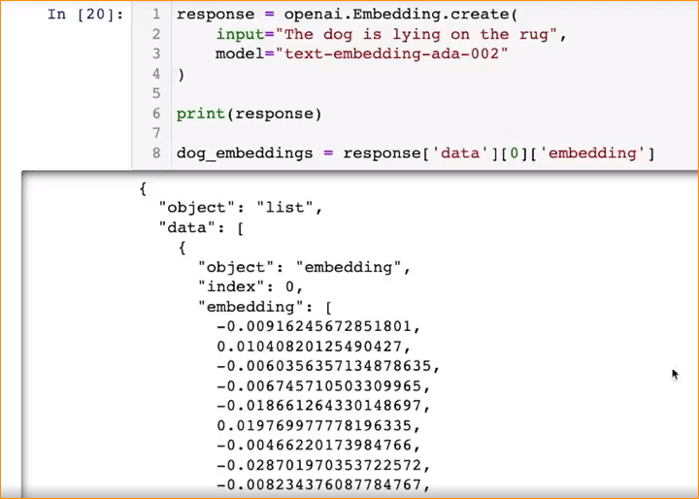

Now check the length – also same

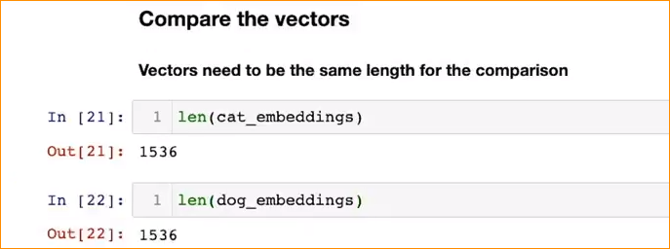

Cosine similarity - is a measure of similarity between two non-zero vectors. Value can be between 0 and 1. Close to 1 mean more similar tow vector each other.

Cosine similarity coming from numpy –

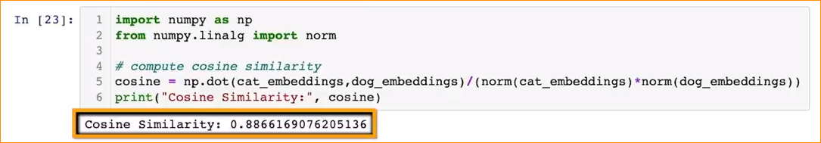

1. **Turn Audio into text using Whisper**

This model trained on 680 000 hrs- 29 days.

Using whisper API we can convert

Audio or speech into text.

Model takes audio files and performs transcriptions.

Enable translation in multiple languages and from those languages to English.

Input MP3 or MP4 and others.

There are 9 models in whisper family.

This model – encoder to decoder model and sequence to sequence model.

Postmen link to access the model –

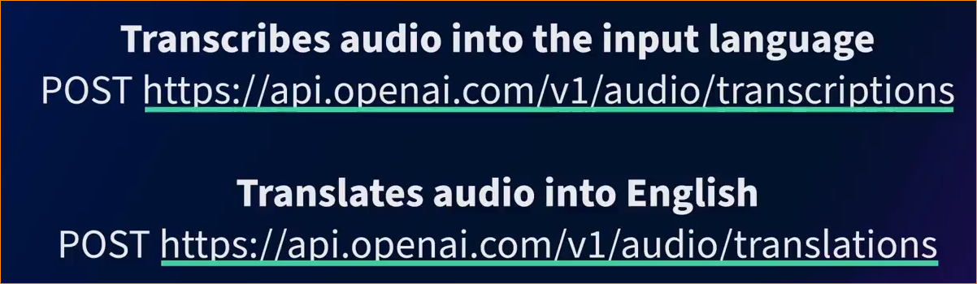

Example –

Import library –



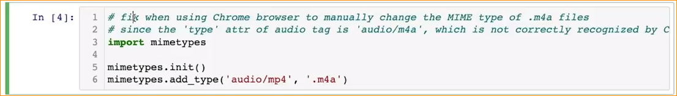

I put audio file – linked in learning

Example 01-

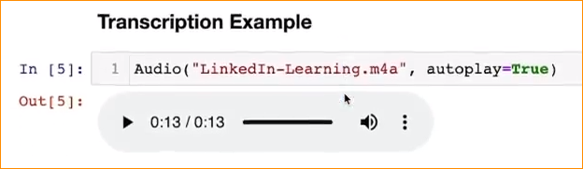

Use whisper to translate that audio file , execute the code and here is the output- translate

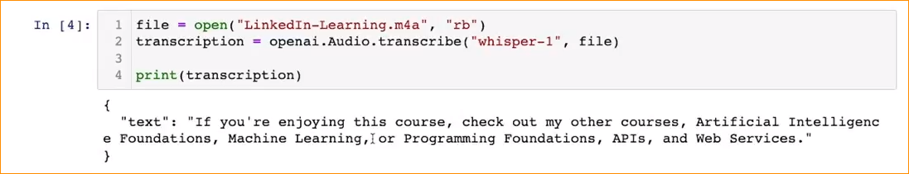

Example 02- language translate

Input – Audio file in Italian

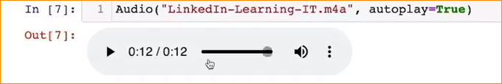

Translate to English –

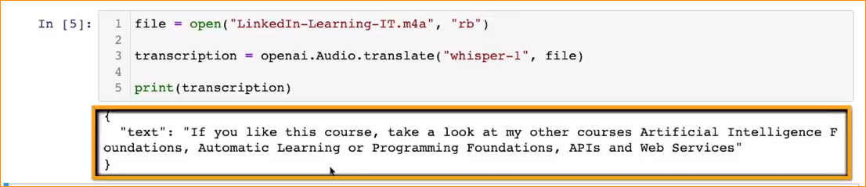

**V. Generate images using Dell-E**

For this we are using AI DELL-E model.

With Dell-E,

* Generate a new images from a text prompt
* Edit or retouch an existing image based on a text prompt.
* Create variation of an existing image.
* Commercialize the images that created.

Process – feed a text prompt to DALL-E and model create 4 images for you.

Access DELL-E-

1. Browser base tool –

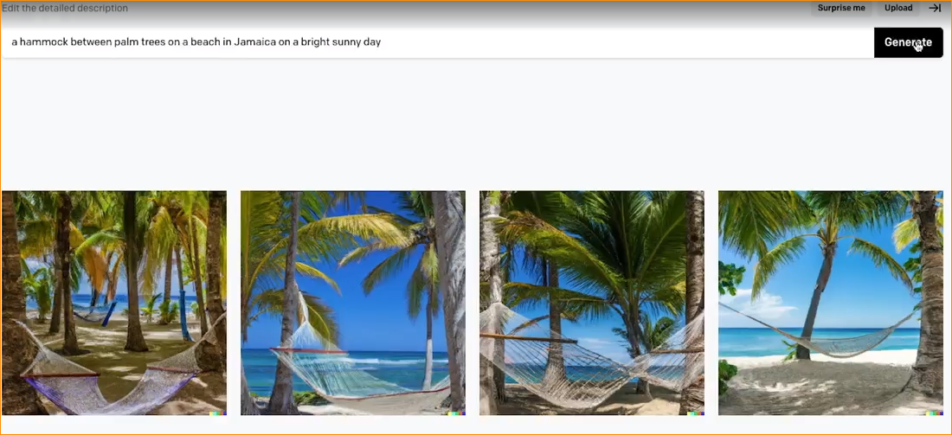

1. OpenAI Images API – DALEE-API

* Access directly through using postman.

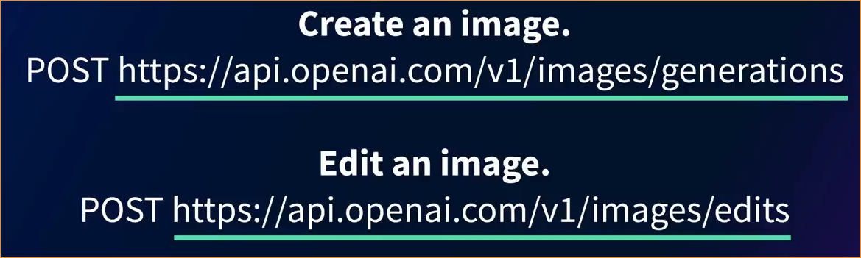

* Python Image generation-

1. Drawing the image -

Prompt – “A rainbow with a pot of gold”, number of images = 1 and adjust the size.

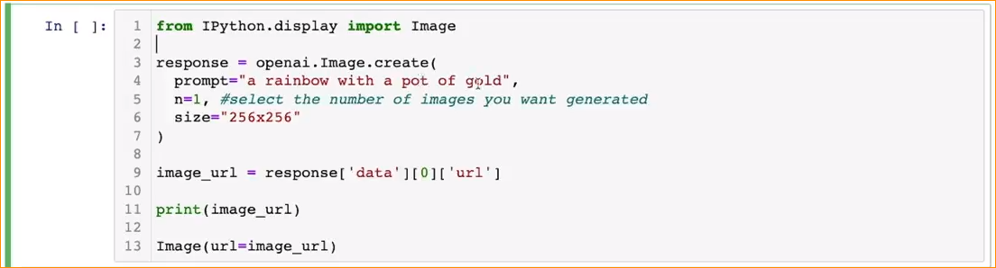

Image-url = store image URL variable

Then print the image.

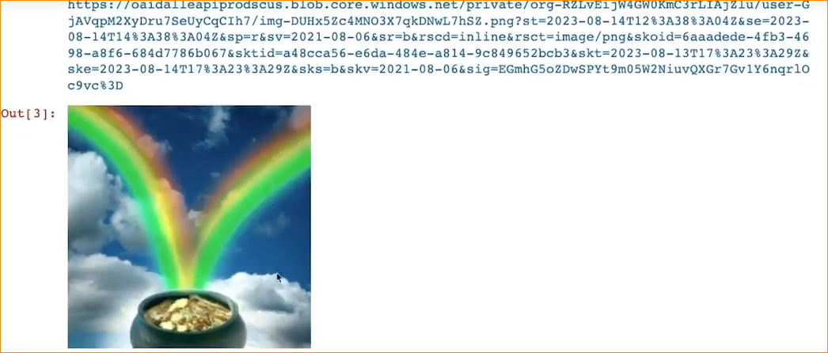

1. Edit the image

Upload my image –



Show the original image –



Edit -

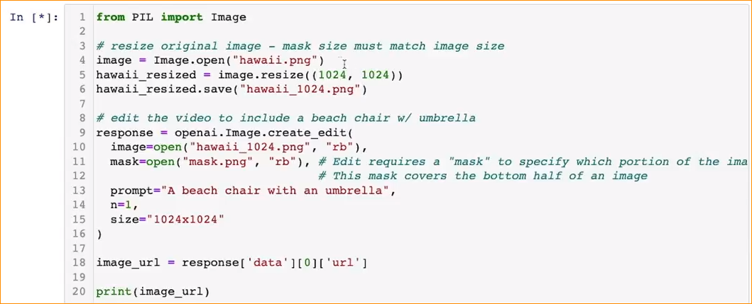

First resize the image using PIL library-

Edit the image – include the beach chair and umbrella.

Prompt –“A beach chair with and umbrella”

Number of images = 1

Resize – 1024x1024

And print

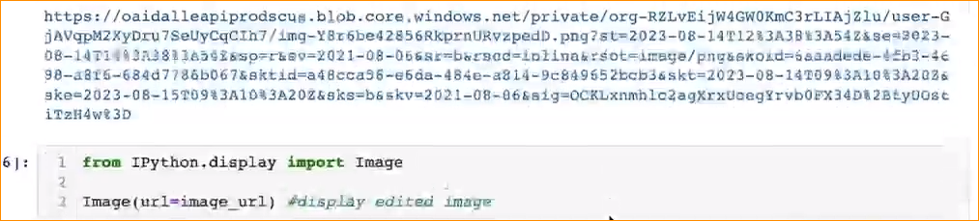

Result –



1. Create image variation-

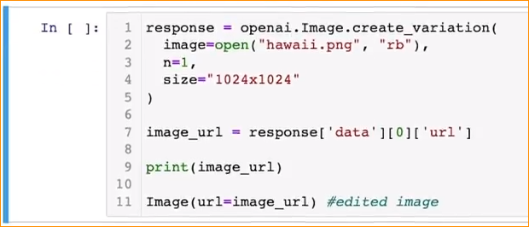

In here we use create_variation API

Original-



Result-

